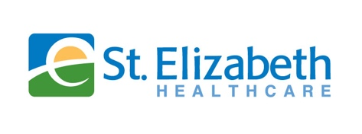
IBD Multi D Meeting
Speakers:
Jai Bikhchandani, MD
St Elizabeth Physicians

Date: October 07, 2025

When: 5:00 PM - 6:00 PM

Where: Microsoft Teams

Targeted Audience: Gastroenterology, Radiology, Pathology, Colon & Rectal Surgery

CME Credits: 1.00 hours.

Contact: Ashley Massman- CME Program Coordinator

Objectives:

1. Enhance Diagnostic Accuracy Through Collaborative Interpretation: Facilitate interdisciplinary review of clinical, radiologic, and pathologic data to improve diagnostic precision and early detection of IBD subtypes and complications.

2. Integrate Surgical and Medical Management in Complex IBD Cases: Promote coordinated care models that incorporate advanced surgical techniques and evolving medical therapies to manage refractory or complicated IBD presentations.

Accreditation Statement:

St. Elizabeth Healthcare is accredited by the Kentucky Medical Association (KMA) to provide continuing medical education for physicians.

Credit Designation Statement:
St. Elizabeth Healthcare designates this Live Activity for a maximum of 1.0 AMA PRA Category 1 Credit(s)™. Physicians should claim only credit commensurate with the extent of their participation in the activity. If you are disabled and have concerns about accessibility or other needs, please contact 301-9751 for necessary arrangements.

Disclosure Statement:
No planners, faculty presenters, reviewers, or others in control of content (either individually or as a group) have any relevant financial relationships with an ineligible company to disclose.

No commercial support has influenced the planning, implementation, or evaluation of the content of this activity.

